**Sabrent Rocket 4 Plus vs. Samsung 980 Pro SSD**

Who Makes the Best PCIe 4.0 SSD for Consumers?

For a long time, Samsung was the clear choice when it came to the best consumer SSD on the market. Sabrent, on the other hand, emerged as a dominant newcomer in our 2019 SSD roundup, hoping to dethrone Samsung. Their Rocket 4 SSD, which performed admirably, was one of our favourites. Even better, it was far less expensive than Samsung's 970 Pro series.

In the year that followed, Sabrent drives grew in popularity and received consistently favourable feedback. We saw that our review of the Rocket 4 was getting a lot of attention from people looking to buy the drive, and they were selling like hotcakes. We're returning to discover which drive is superior now that both Samsung and Sabrent have updated their product lines with the SSD 980 Pro and the Rocket 4 Plus, respectively.

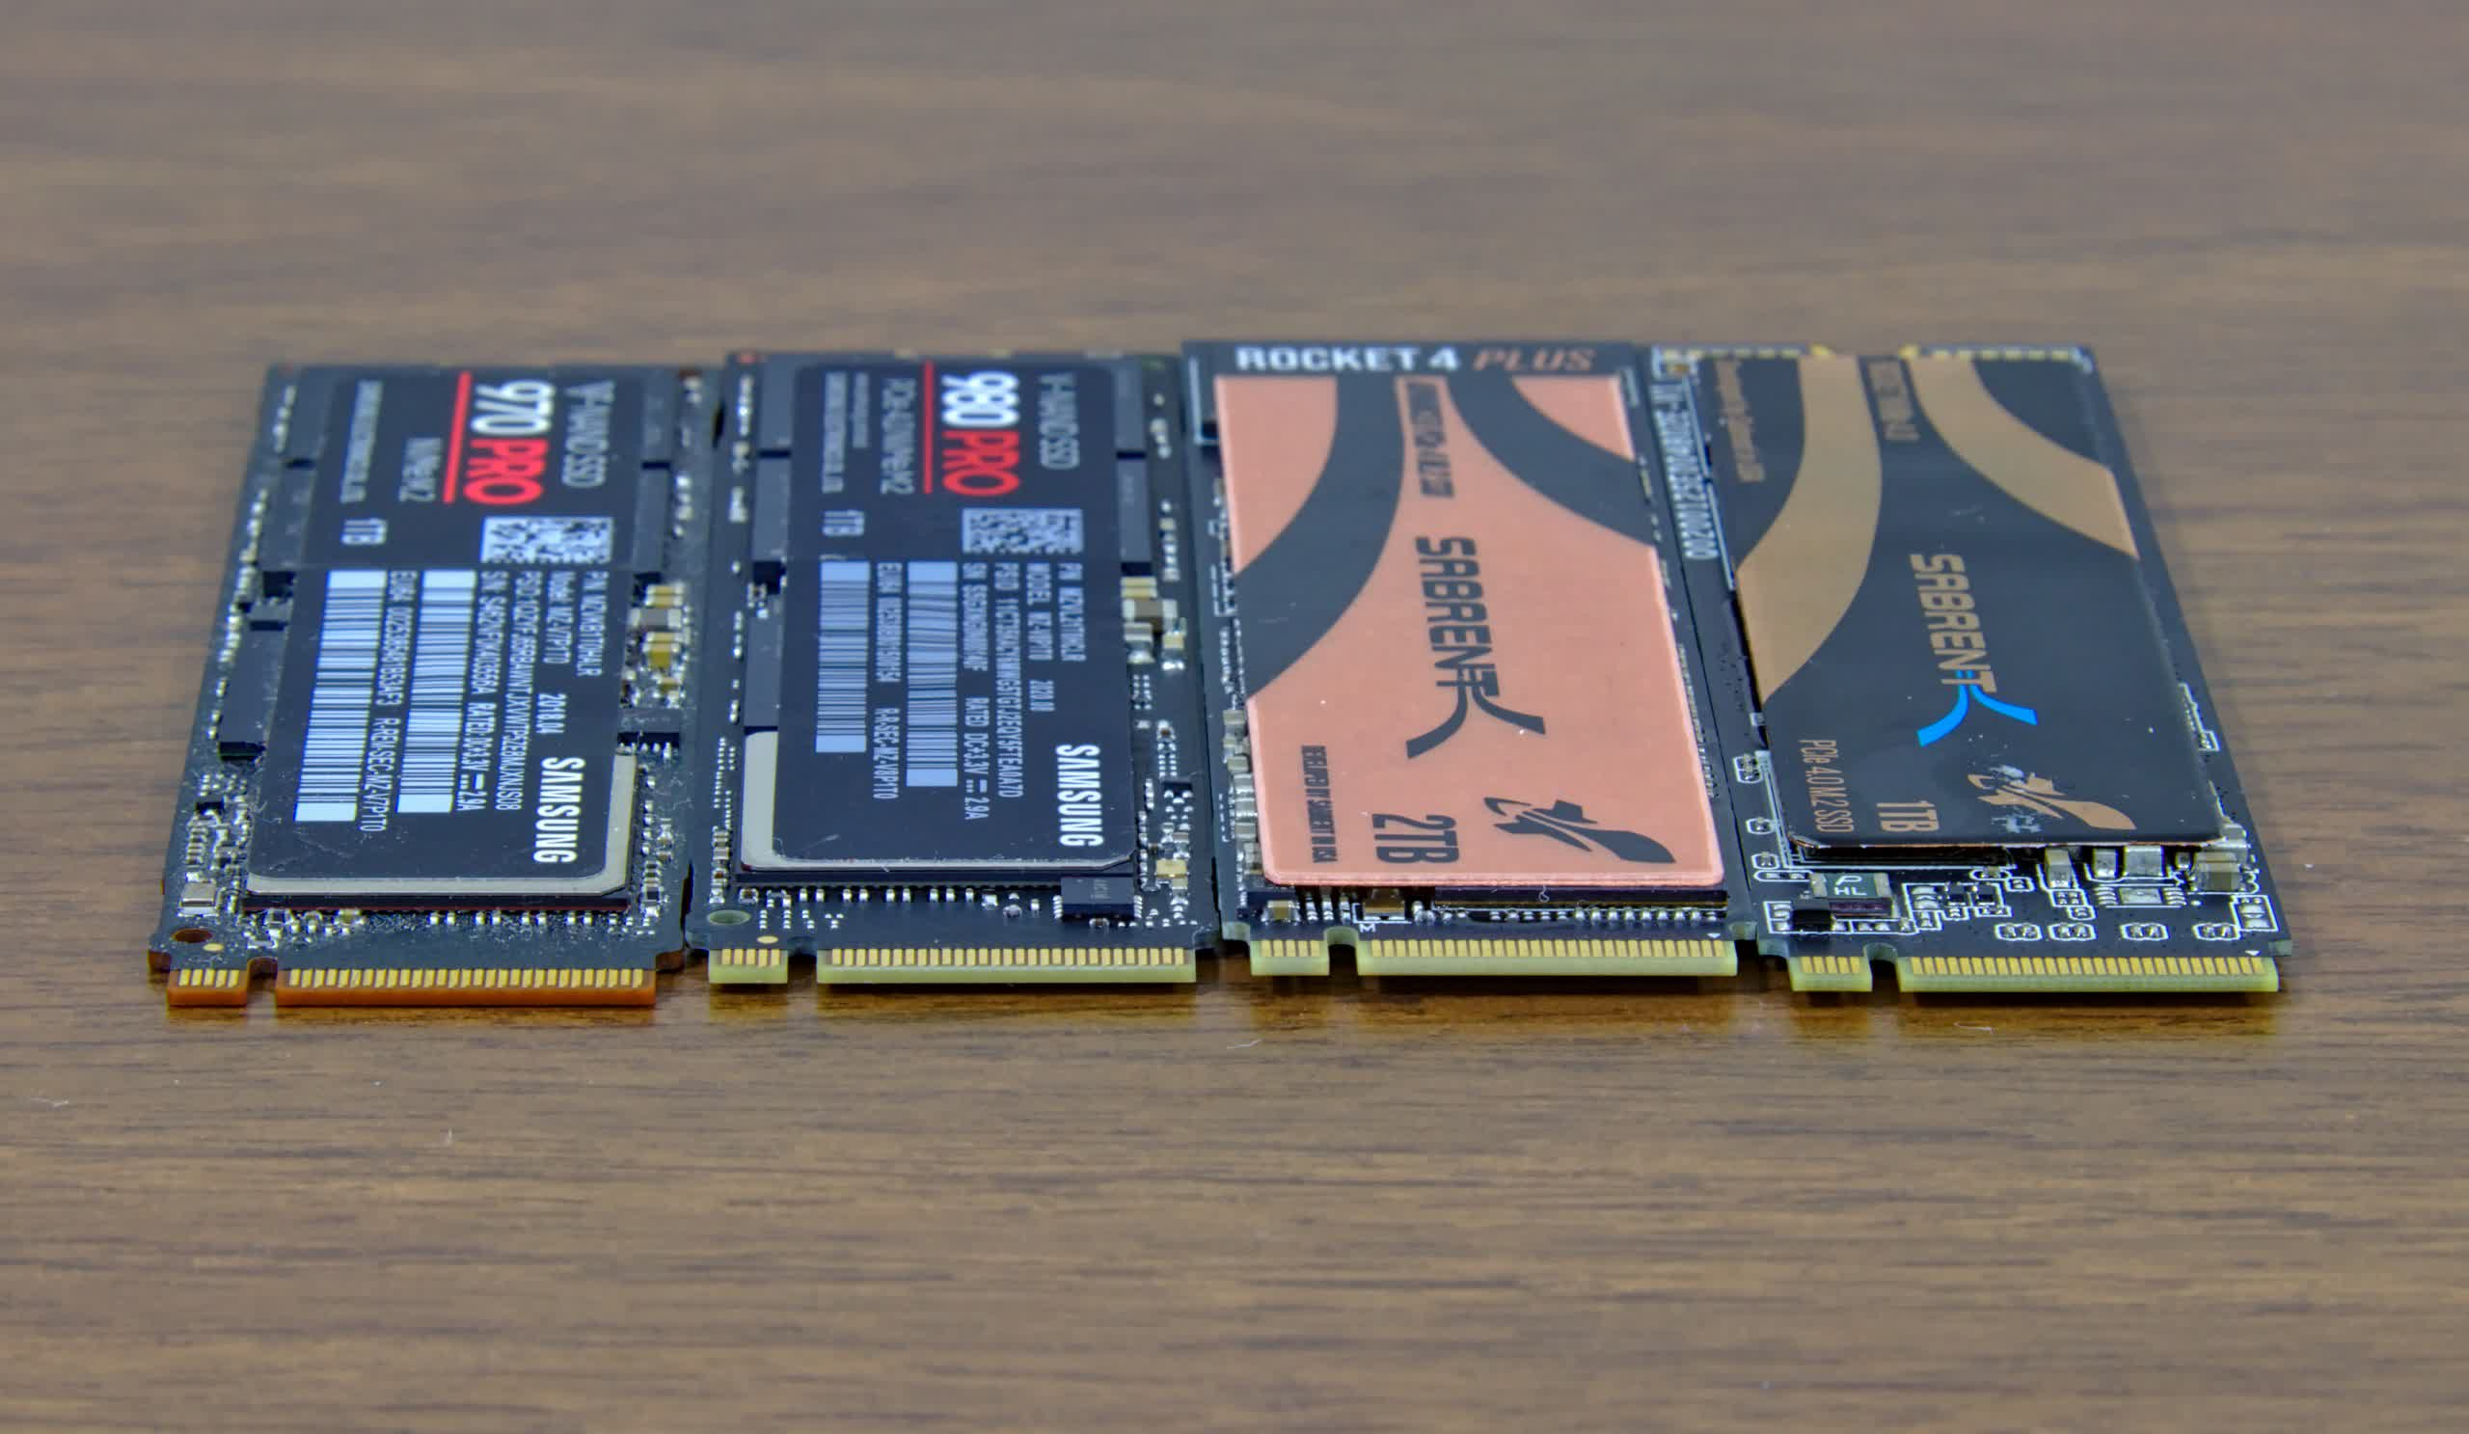

In a series of tests, we'll compare Samsung's 970 Pro and 980 Pro, as well as Sabrent's Rocket 4 and Rocket 4 Plus. We chose the Origin Neuron gaming desktop, which we previously reviewed, as our testbed, and all drives were configured up with the same Windows 10 image. A Ryzen 7 5800X processor, 16GB of RAM, and an Asus ROG Crosshair VIII Hero motherboard are included in this setup.

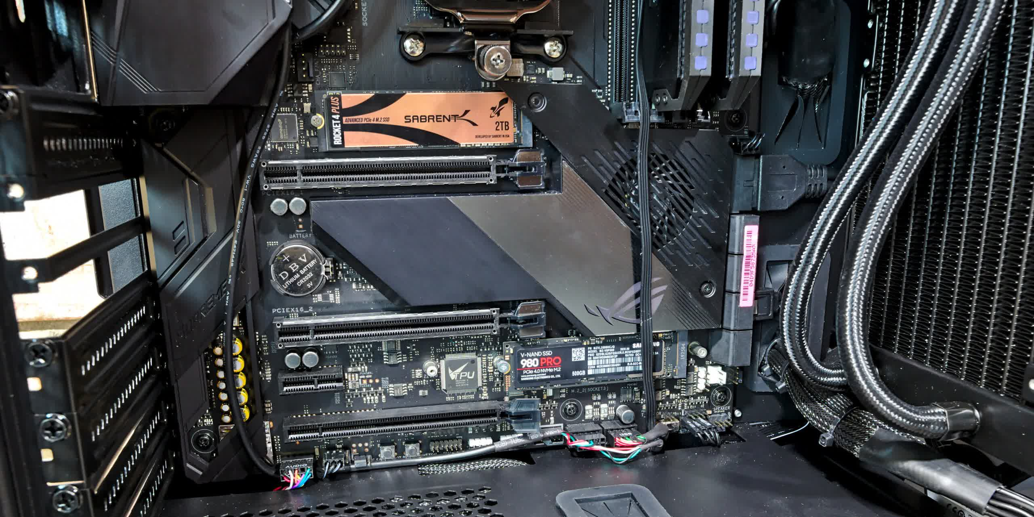

On the Asus motherboard, there are two SSDs. Note that we used the higher slot for all of our experiments.

**Performance**

We began with an Anvil synthetic test that analyses speed, response time, and IOPS in a variety of setups. The results are added together to arrive at a final performance figure.

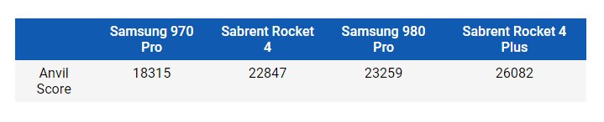

As a result, we should expect the Rocket 4 to perform similarly to the 980 Pro. The 970 Pro is roughly 20% slower, while the Rocket 4 Plus is 10% to 15% quicker.

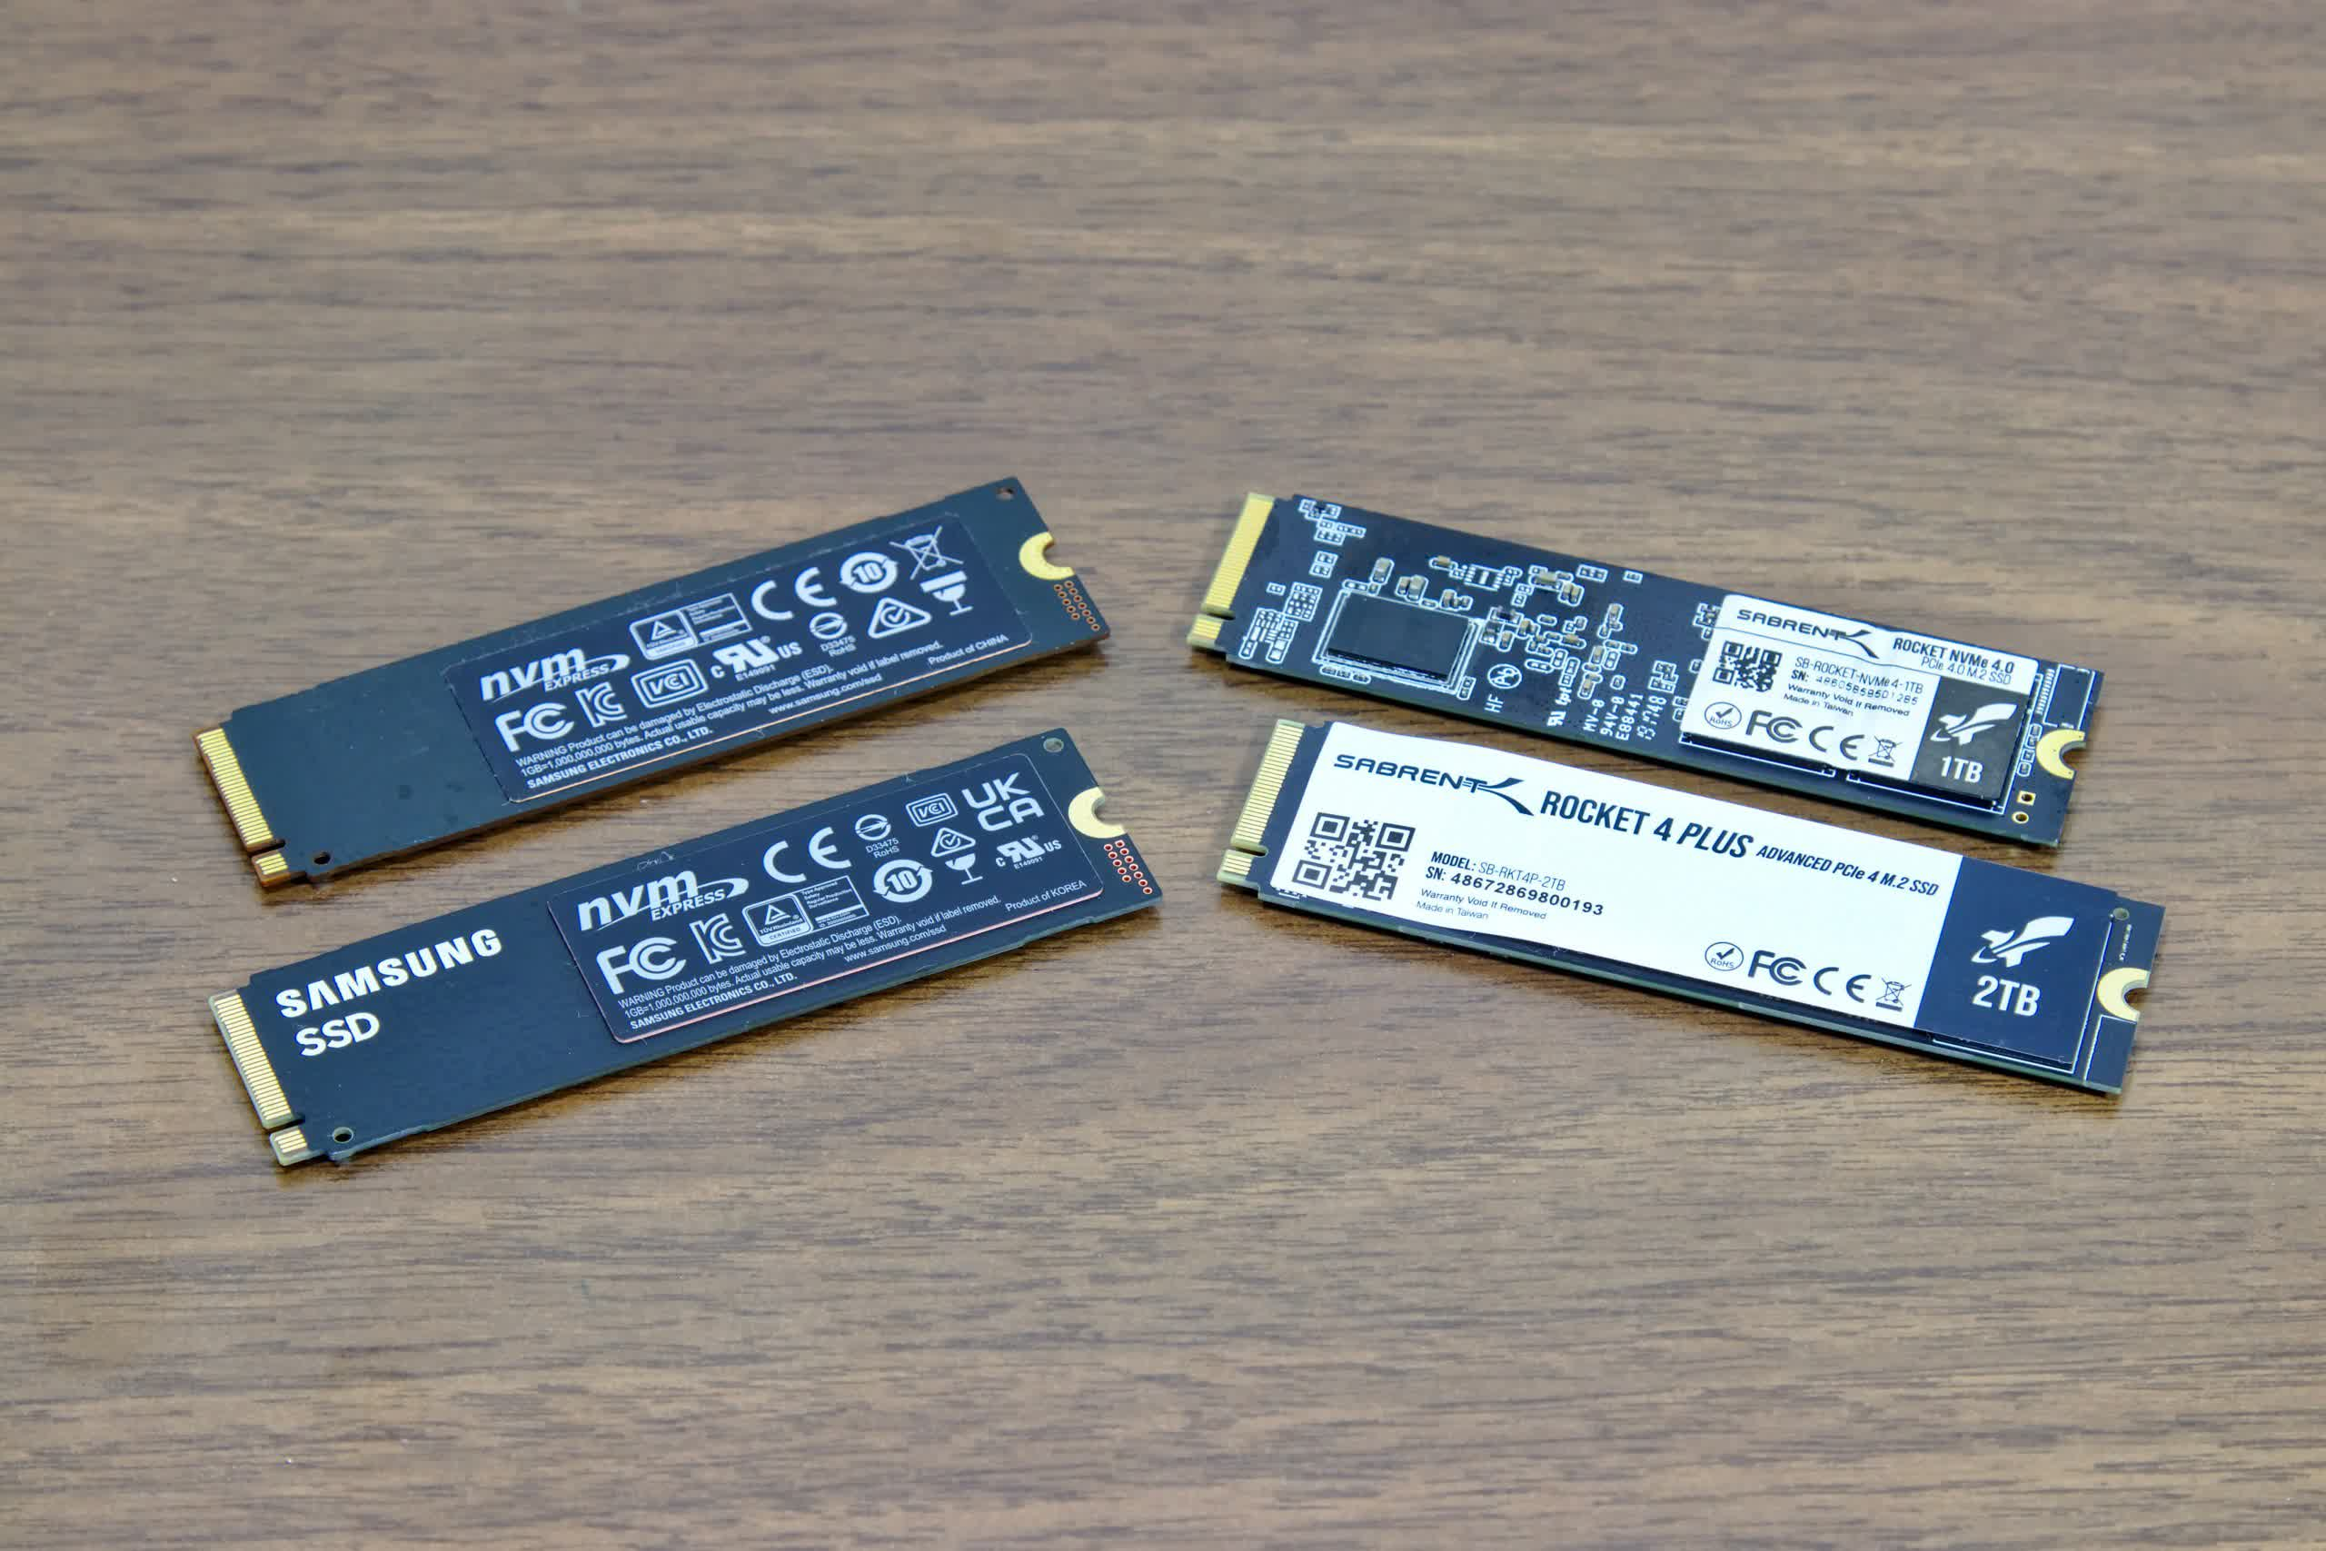

Let's have a look at typical read and write speeds for various file sizes. The 970 Pro's maximum read speed is 3500 MB/s, while its maximum write speed is 2700 MB/s. It's 5000 MB/s read and 4400 MB/s write for the Sabrent Rocket 4 (a PCIe 4.0 drive).

The Samsung 980 Pro has a read speed of 7000 MB/s and a write speed of 5000 MB/s, whereas the Sabrent Rocket 4 Plus has a read speed of 7100 MB/s and a write speed of 6600 MB/s. These figures are similar to Wi-Fi speed ratings in that they are simply guidelines that you will never achieve.

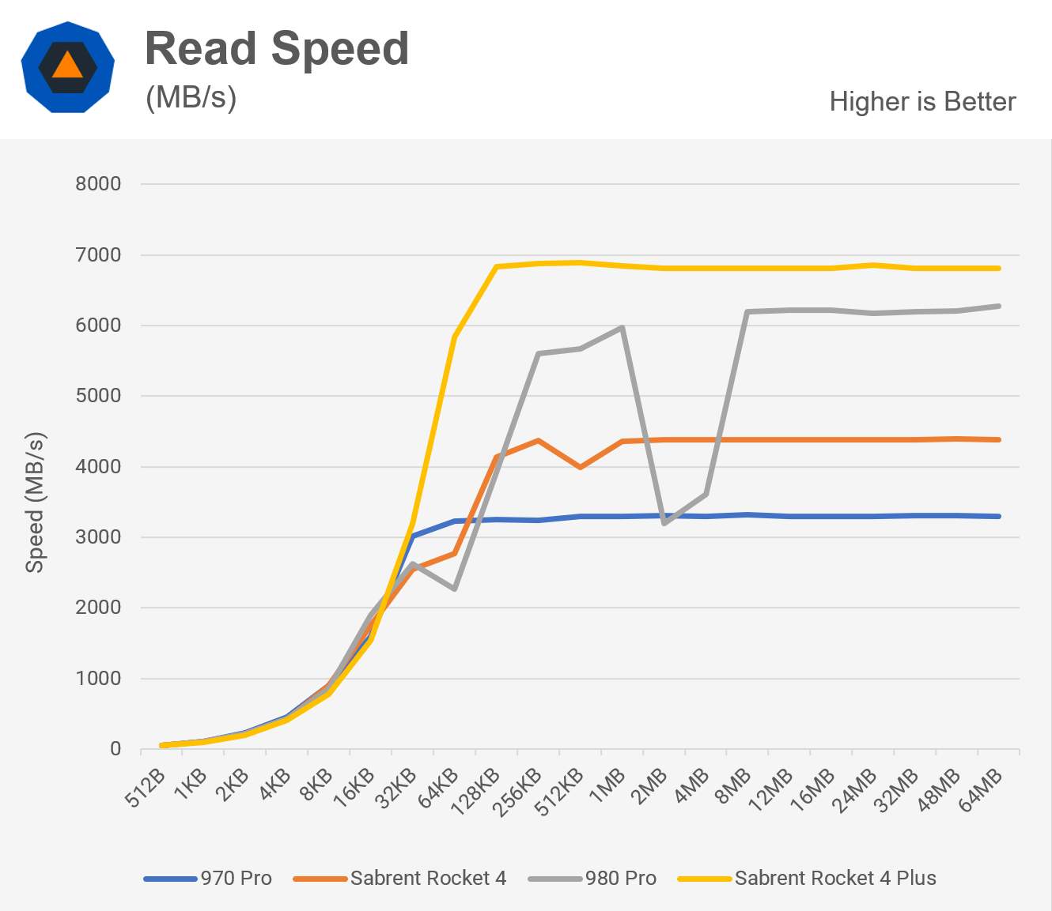

According to our measurements, the 970 Pro is extremely close to the specification. Both reads and writes are around 10% slower on the Rocket 4. The 980 Pro is a fascinating device. It never got above 6300 MB/s in the read test, and our equipment had an odd speed dip with files smaller than 2-4MB. It marginally outperformed its rating in the write test for 64KB files, but fell short of the target for larger files by around 10%. In both testing, the Rocket 4 Plus came extremely close to meeting the specs rating and is the clear winner on paper. Keep in mind that these are hypothetical tests, and actual results will be lower.

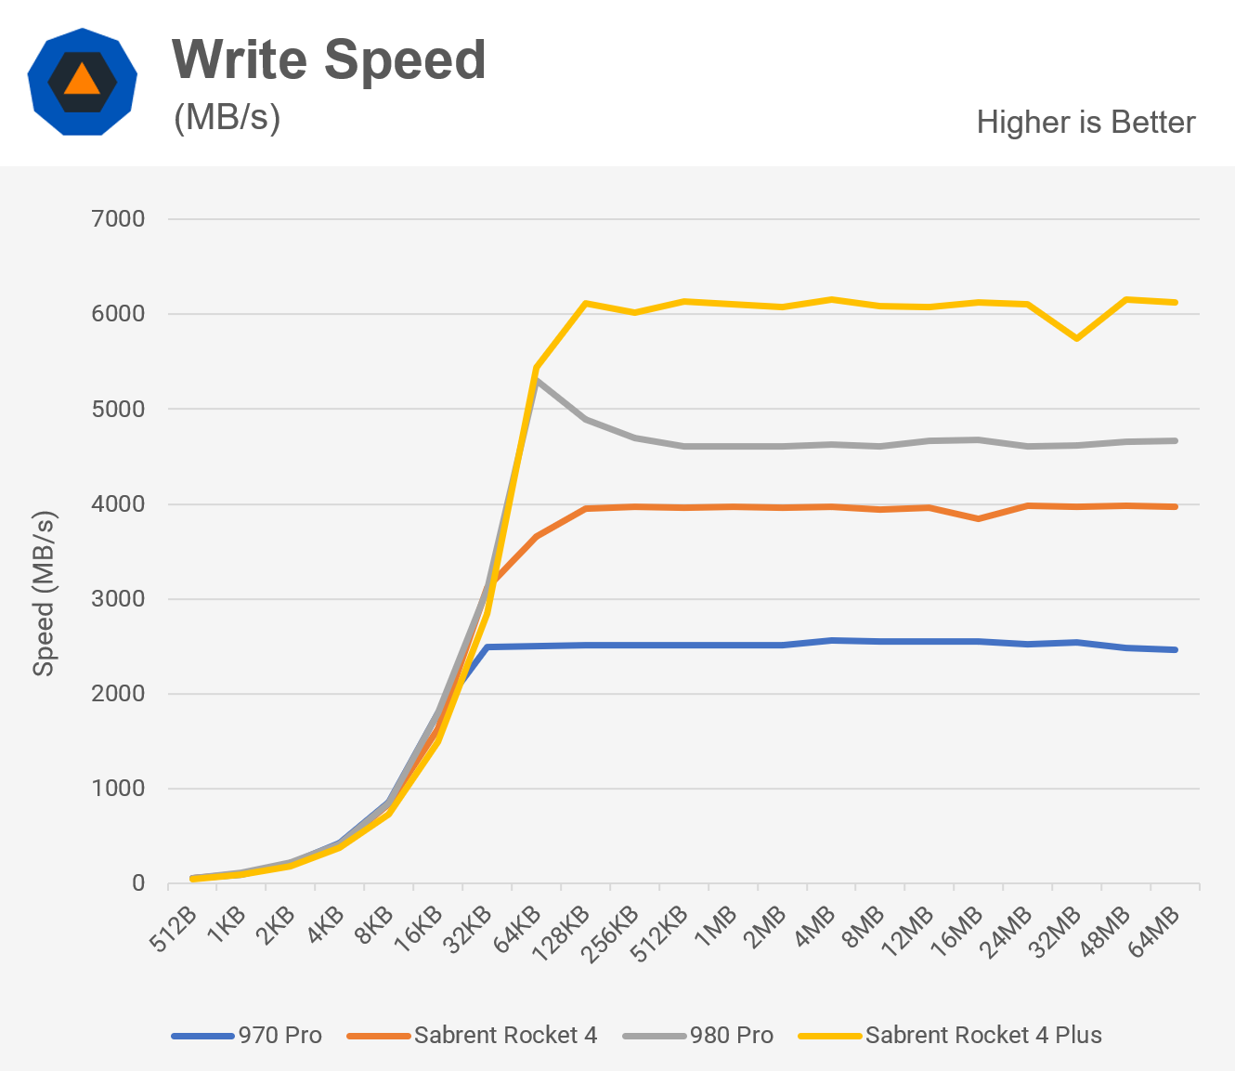

Then we'll look at reaction time. Consider it similar to pinging your SSD. It doesn't matter whether you have a fast internet connection if your ping is too high to do anything productive.

The same idea applies to drives, which represents the time it takes for the drive to reply to a request. Both 4MB and 4KB files provide the same results.

When compared to newer drives, the 970 Pro suffers, and the Rocket 4 isn't much better. This diagram depicts the evolution of storage controller design through time. Although the 980 Pro and Rocket 4 Plus are quite close, Sabrent comes out on top. Although a fraction of a millisecond may not seem like much, when a drive processes hundreds or more data every second, it adds up.

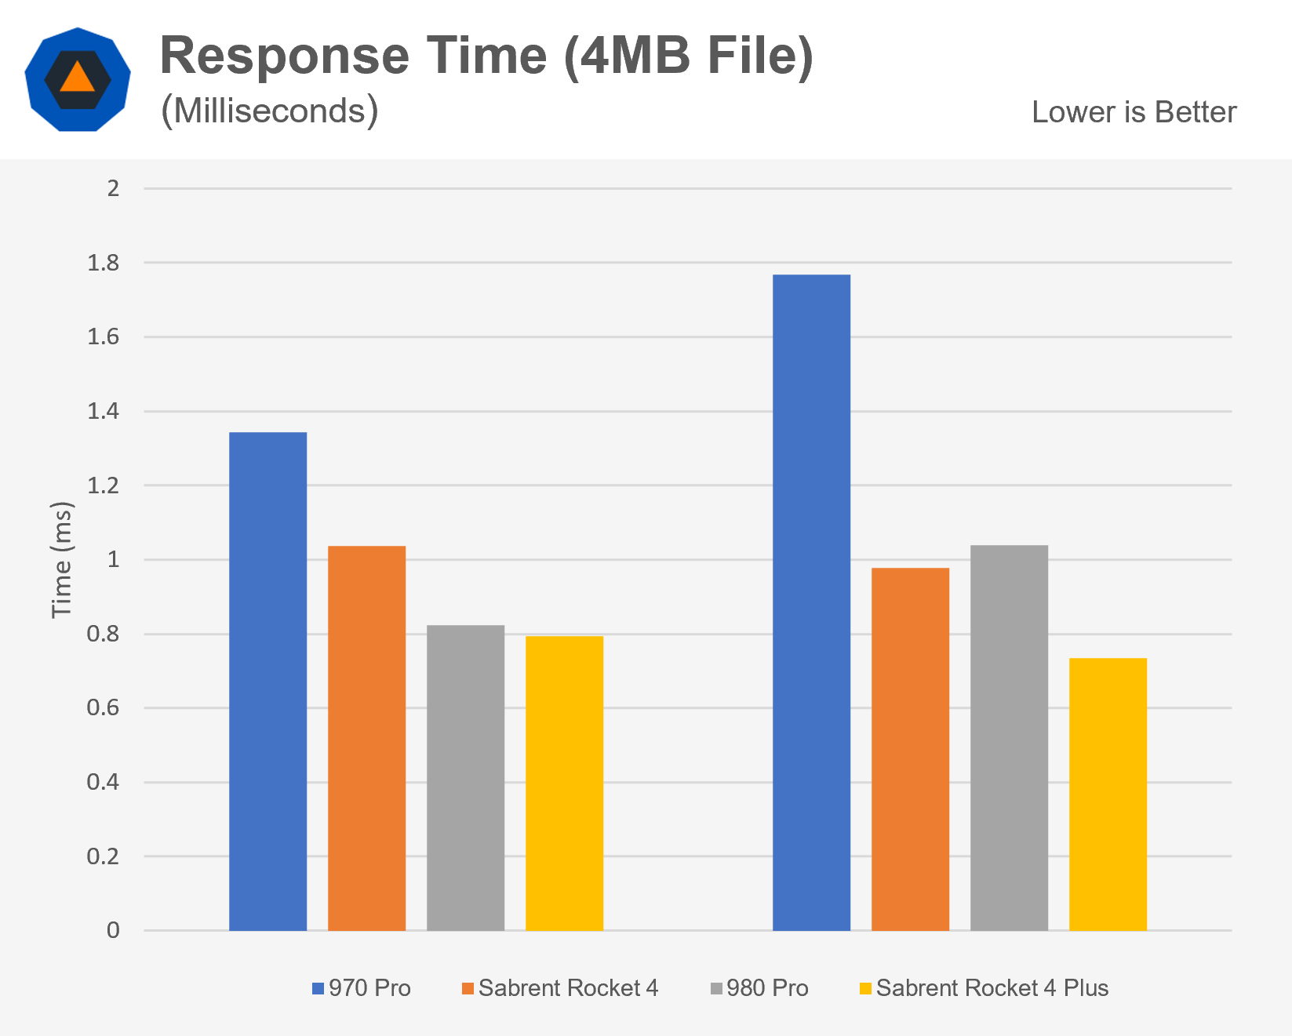

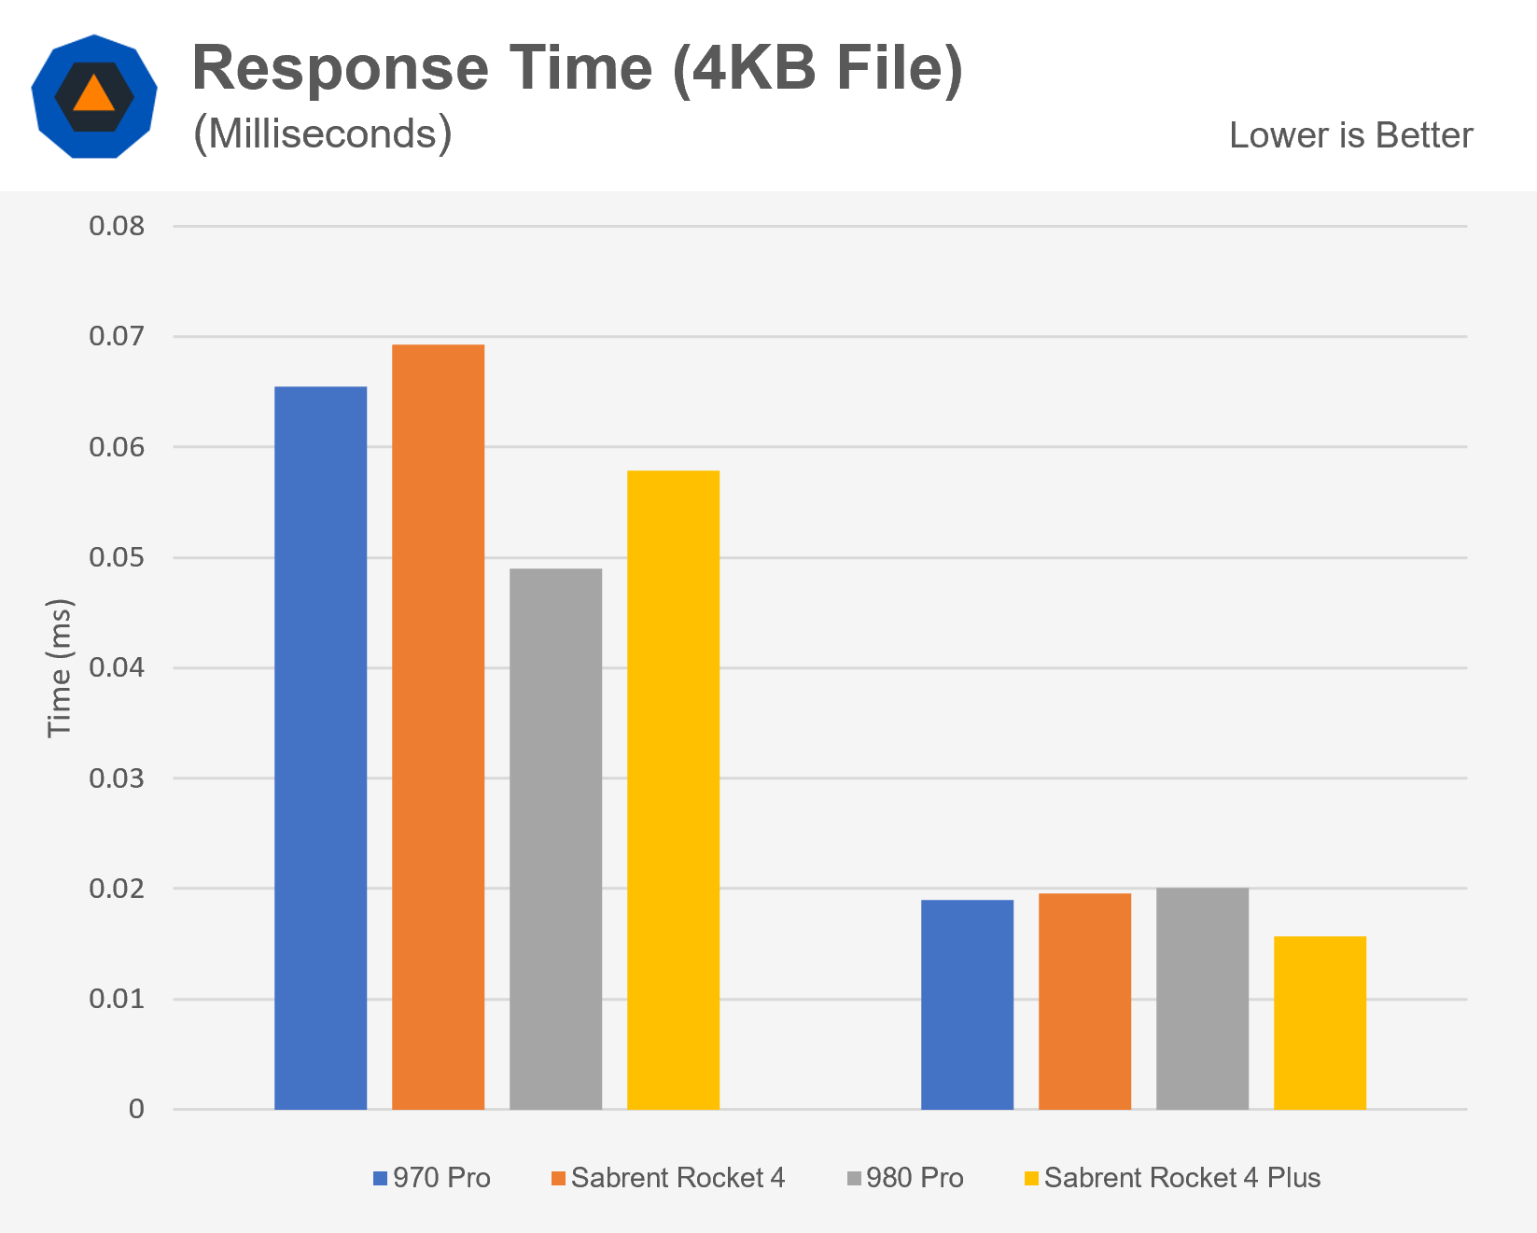

The synthetic testing are now complete.

Now we'll look at numbers for tests that are more realistic. The average time it took to copy a collection of files from one partition on the drive to another is represented in the next two tests.

**Tests in the real world and in video games**

We utilised a regular CS:GO installation for the game copy test. It contains thousands of files of various sizes and occupies approximately 34GB of disc space. We used a couple dozen movie clips for the media copy test, which took up 34GB as well. Because data is read and written at the same time, this test will yield substantially lower results than the drive's rated values. In each direction, you're effectively obtaining half of the drive's specified throughput.

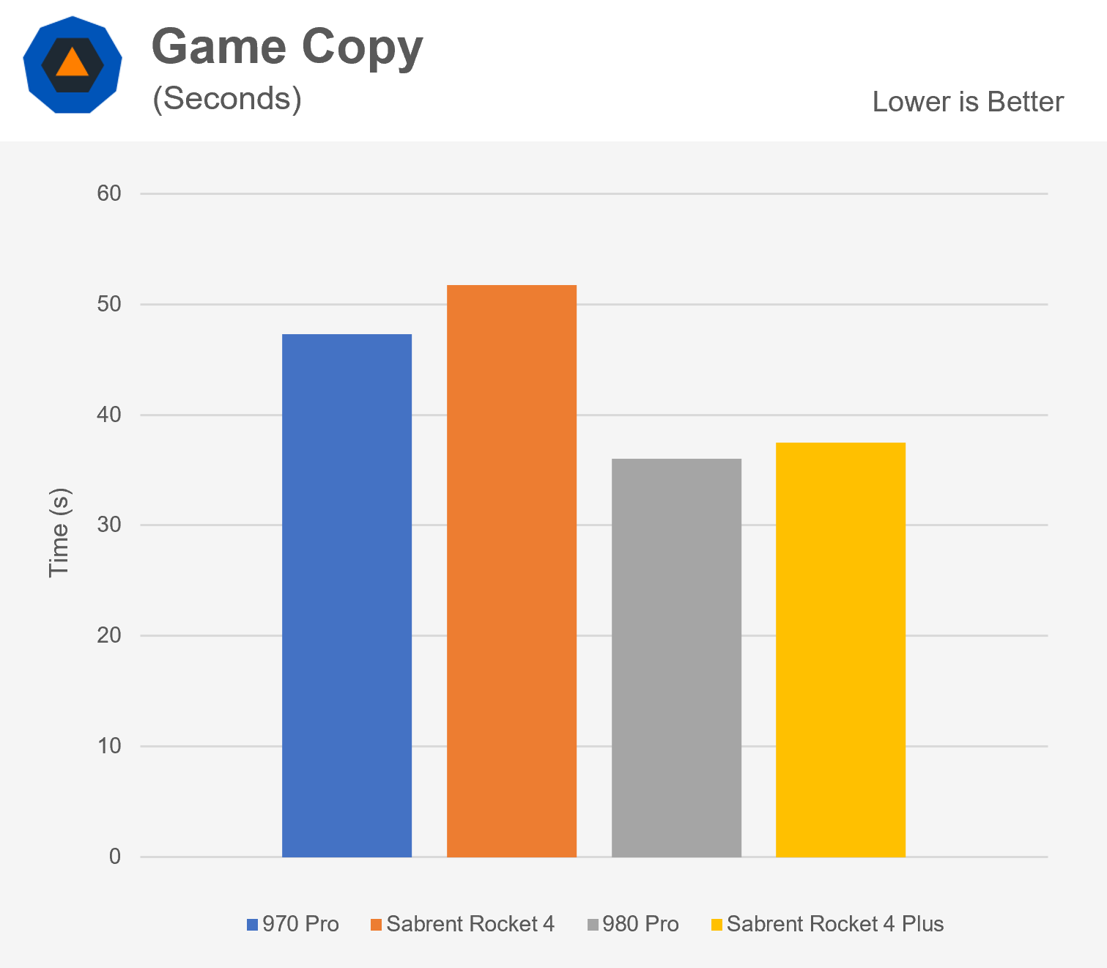

It's worth noting that, despite the fact that both experiments copied the same amount of data, the game took nearly twice as long. This is due to the extra time and effort required to locate and process thousands of files.

In both tests, Samsung's 980 Pro came out on top, with the Rocket 4 Plus trailing by a few seconds. When comparing the previous generation drives, we can find that the Rocket 4 is faster when copying large files while the 970 Pro is faster when copying smaller files.

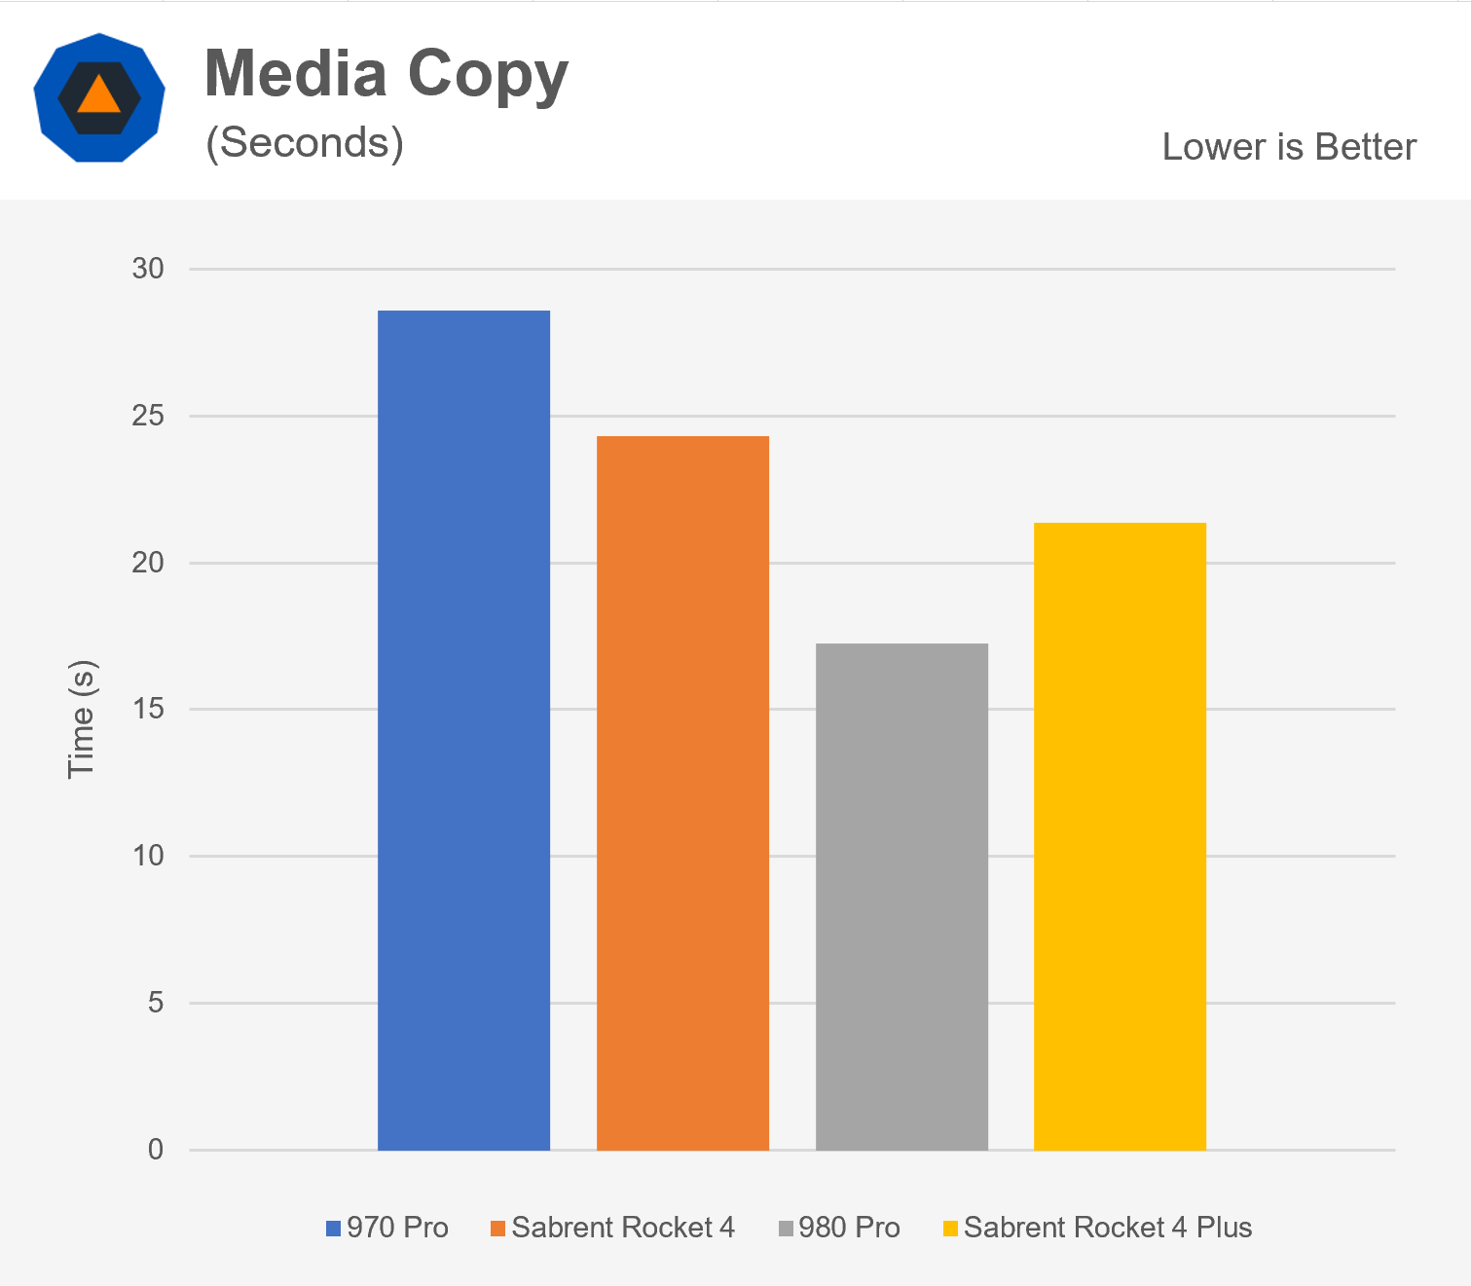

The following test we ran was a script that encrypts data, writes the results to a new file, decrypts it, and then checks the file's hash. On current systems, encryption is a workload that occurs frequently. It's also significant since it denotes a task in which data must be transferred to the CPU for processing.

When you copy a file, the data doesn't have to leave the SSD because it's cached. The interface between the SSD and the rest of the system is used with encryption. This test yielded virtually identical results. Even though the SSDs have vastly disparate performance statistics, they all complete the task at the same time in this example. Increased storage performance isn't necessary for all applications.

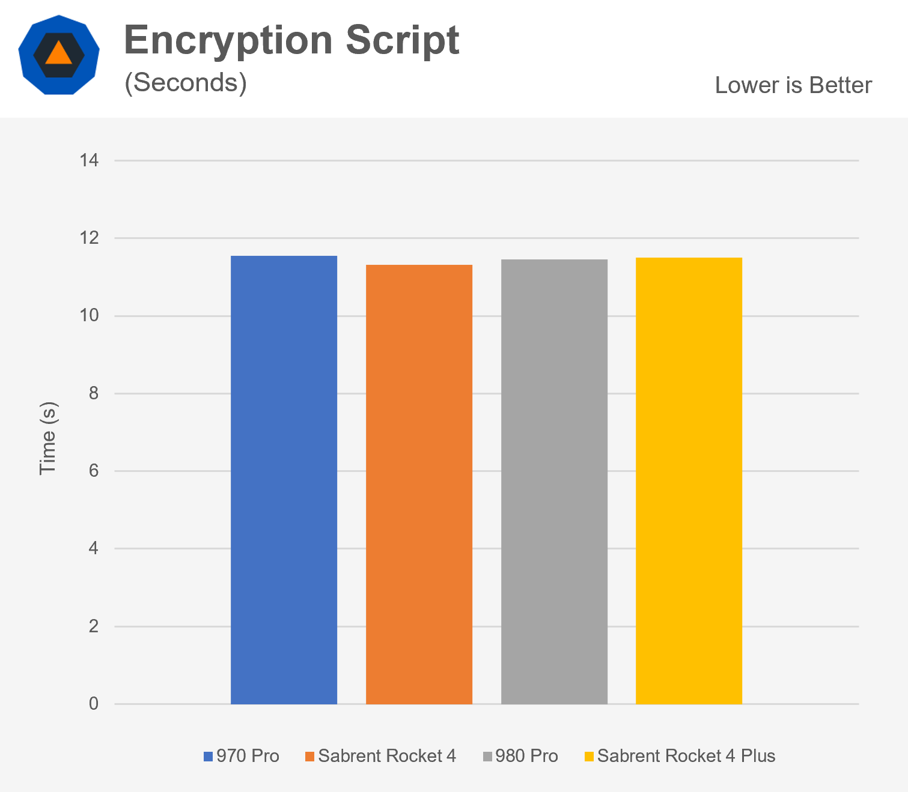

It's a mixed bag when it comes to boot camp. Two cold boots (beginning with power unplugged) and two warm boots were averaged to arrive at these figures (shutdown and restart without unplugging power). Each of the four drives took less than 1.5 seconds to complete.

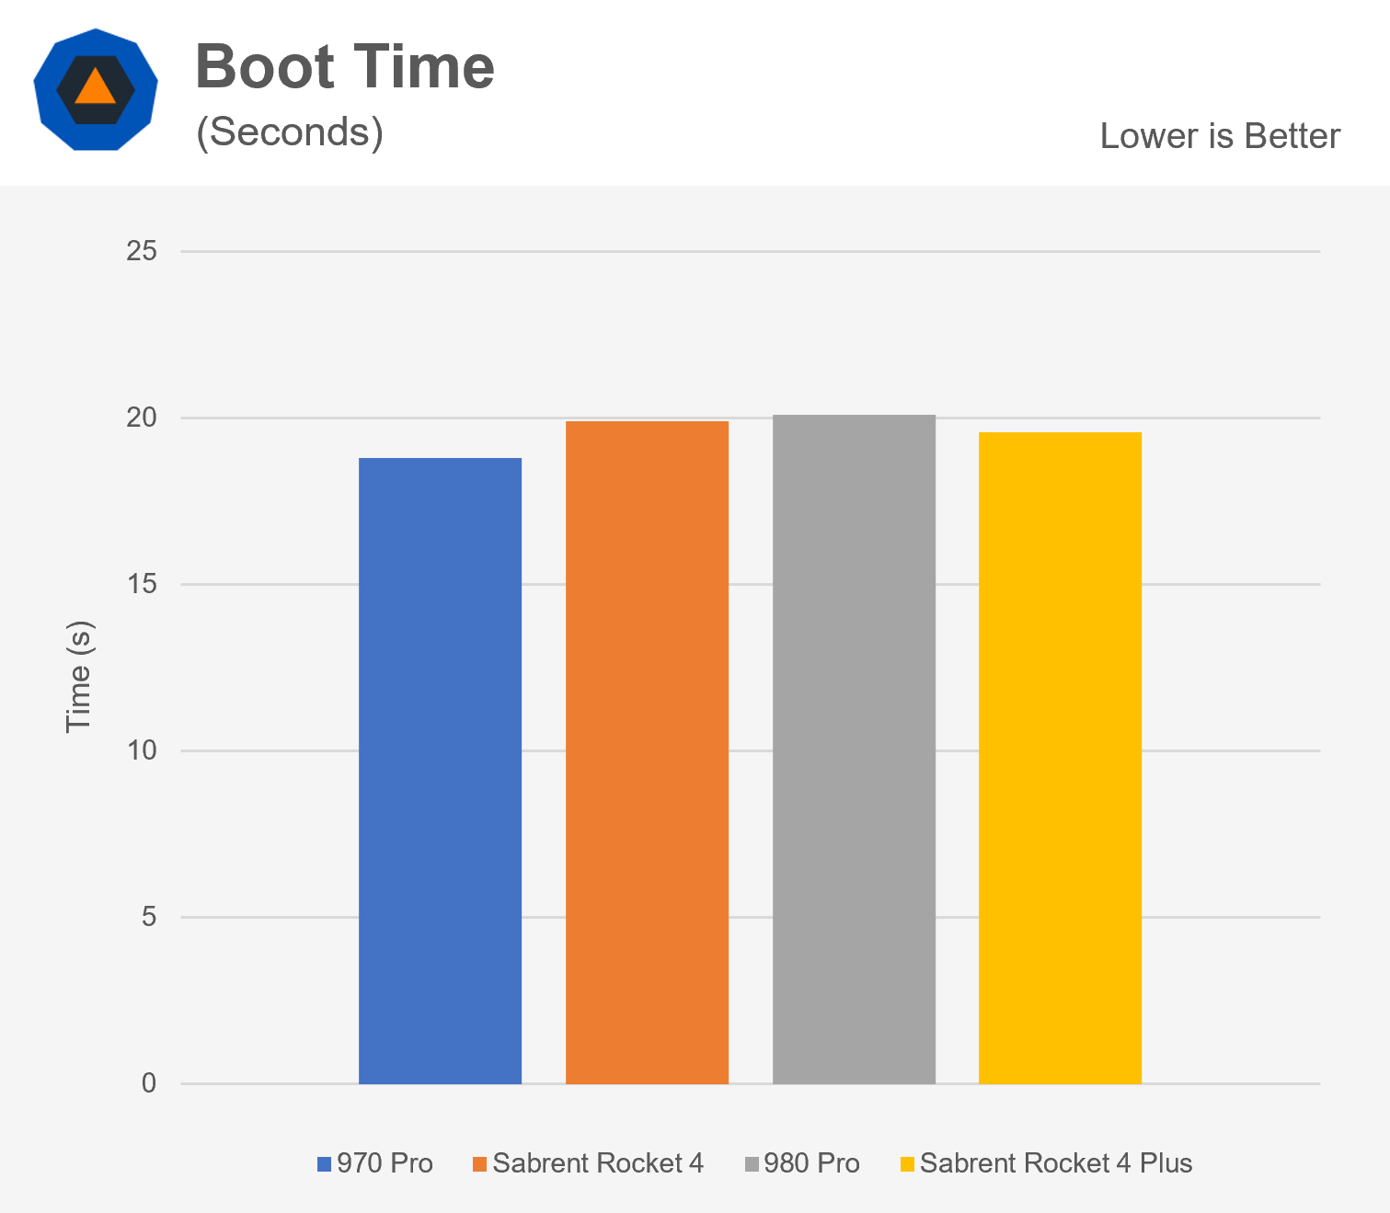

Let's take a peek at some gaming statistics right now.

We put the system through its paces with Microsoft Flight Simulator 2020, a game known for its massive files and environments. The first test consisted of just running the game from the computer's desktop. Both the Samsung and Sabrent models show a minor generational improvement here.

However, there isn't much gain for a game that takes nearly two minutes to load. Starting the game engine, which has a lot of little files, is the most time-consuming part of loading the game. When we choose a map/mission, the larger textures will be loaded later. This one is won by the 980 Pro by a few seconds.

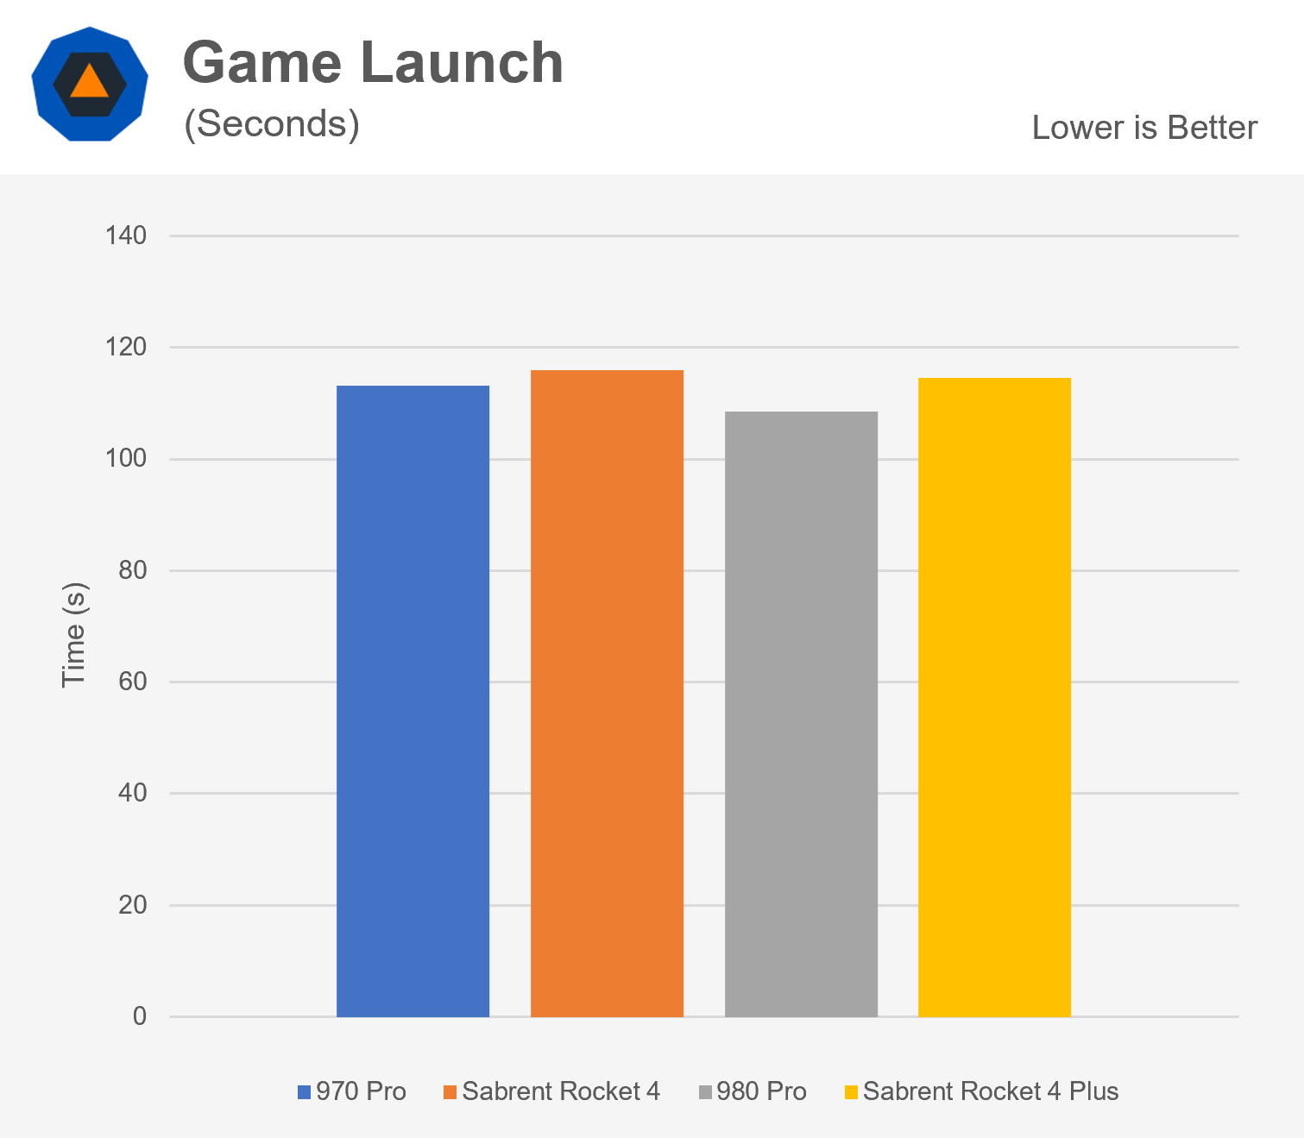

The second test we did was to see how long it took to load into a scenario and start flying after the game had loaded. The mission we used was the Jackson Hole landing challenge. Here, the two Sabrent drives win by a whopping 20% margin. This suggests that the Sabrent drives are better at processing a few large files, whereas the Samsung drives are better at processing a large number of smaller files.

We can add both of these numbers together to generate an estimate of how long it would take to transition from desktop to in-game. Surprisingly, the Rocket 4, 980 Pro, and Rocket 4 Plus all completed in under 140 seconds, with the 970 Pro just edging out the 980 Pro at 144 seconds. This demonstrates that, despite the large amount of data the game need to load, the top three drives function identically.

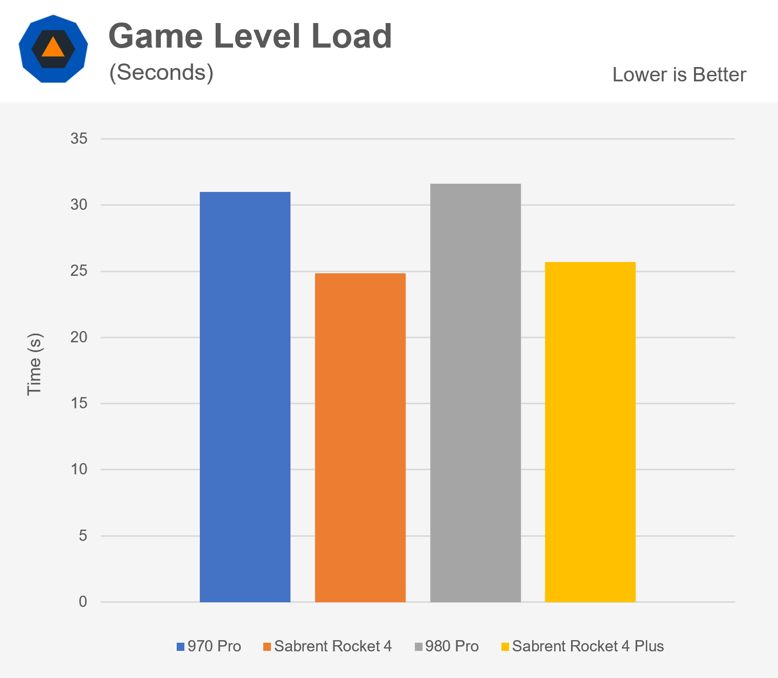

The most recent test we conducted was a torture test. Some drives have a small amount of very fast RAM that caches frequently accessed data. This enables the maker to employ slower bulk storage while yet appearing to be quick in some workloads. A design like this may be found in cars like the 970 Evo. It performs admirably for tiny file transfers, but once the cache is full, speed suffers noticeably.

During the test, we made ten copies of randomly generated 100GB files, deleting and rebuilding them after each cycle. This amounts to a total of 1TB of reads and 1TB of writes.

For comparison, the 970 Pro has a 1200TB written lifespan, the Rocket 4 has 1800TB, the 980 Pro has 600TB, and the Rocket 4 Plus has 1400TB. It's worth noting that the newer drives have a shorter lifespan than the older drives. We're not sure why this is the case for the Sabrent drive, but in Samsung's case, the 980 Pro is more of a follow-up to the 970 Evo, which featured 3-bit MLC as well (aka TLC).

We would witness a performance drop halfway through if the drives were using a cache or had poor heat management. Fortunately, none of the discs have that problem, but the 980 Pro did slow down around 200GB. The Rocket 4 Plus took just over 400 seconds to complete the test, with the 970 Pro following closely behind. With a time of slightly over 550 seconds, the 980 Pro came in third. The Rocket 4 was a huge letdown here, taking twice as long as the subsequent drive.

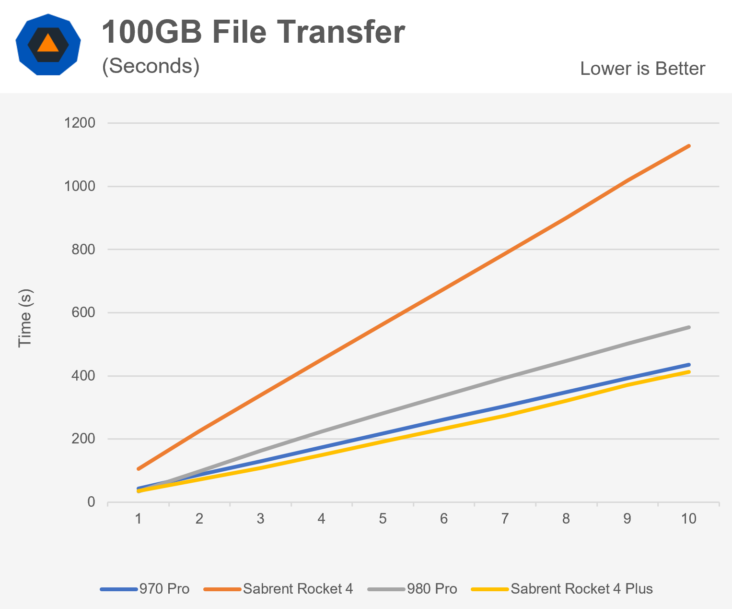

**Choosing a Solid State Drive**

Pricing is the final graph and data table to examine, and it may be the most crucial to consumers. The cost per GB for each drive version at the time of publication is shown here. Below the graph is a table with the current prices for each drive and capacity.

The Sabrent Rocket 4 is the cheapest drive per gigabyte, followed by the Sabrent Rocket 4 Plus. The SSD 980 Pro is only slightly more expensive than Sabrent's best, but the 970 Pro is the more expensive option due to the 2-bit MLC used on that drive. This was Samsung's decision for the new series, with the 980 Pro catering to both high-end mainstream and performance-oriented enthusiasts, while enterprise products would have longer-lasting drives.

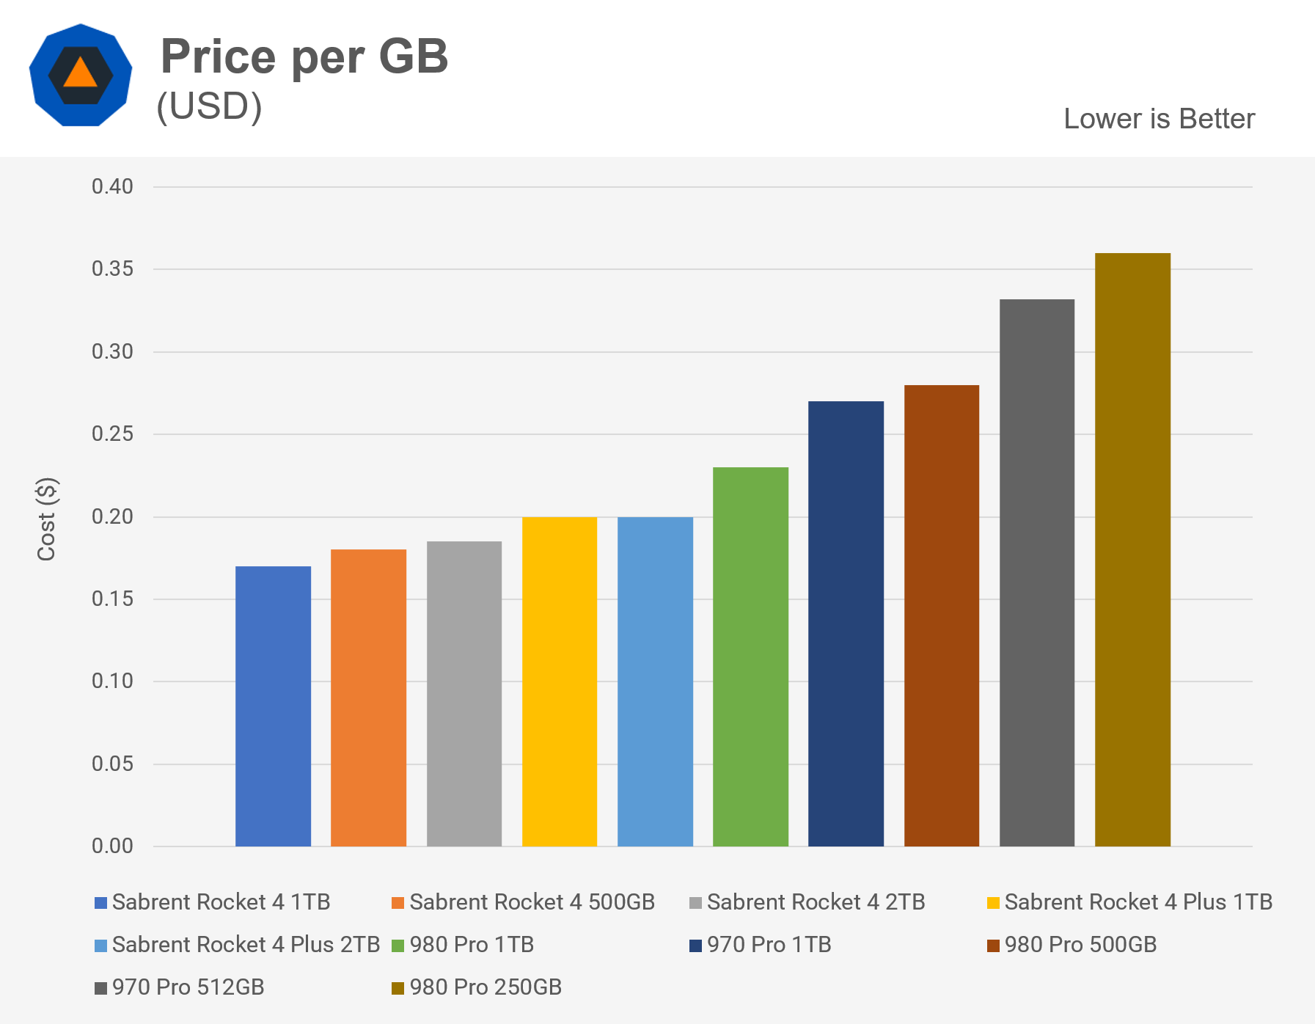

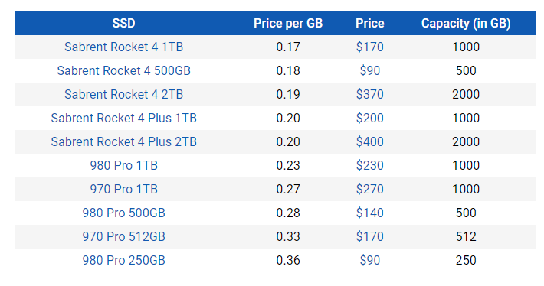

It's difficult to choose between the Samsung 980 Pro and the Sabrent Rocket 4 Plus because they're both reasonably priced and have the best performance of any consumer SSD on the market right now. With the previous generation, Sabrent had the upper hand in terms of value and performance, but Samsung has caught up and is now quite competitive. In fact, without the performance boost provided by the new Rocket 4 Plus, Samsung would earn the top spot.

In file copying, the 980 Pro was marginally faster, but in all other tests, it was a tie. Although the Sabrent Rocket 4 Plus is speedier in synthetic benchmarks, we doubt you'll notice any difference in everyday use. Depending on the price, any option would suffice.

Furthermore, both of these drives are at the top of the SSD food chain for consumers. Check out our past storage testing comparing game load times, testing PCIe 4.0 vs. PCIe 3.0 SSDs, and a storage performance roundup where we tested everything from a mechanical disc drive to mainstream, and high-end SSDs for additional perspective.

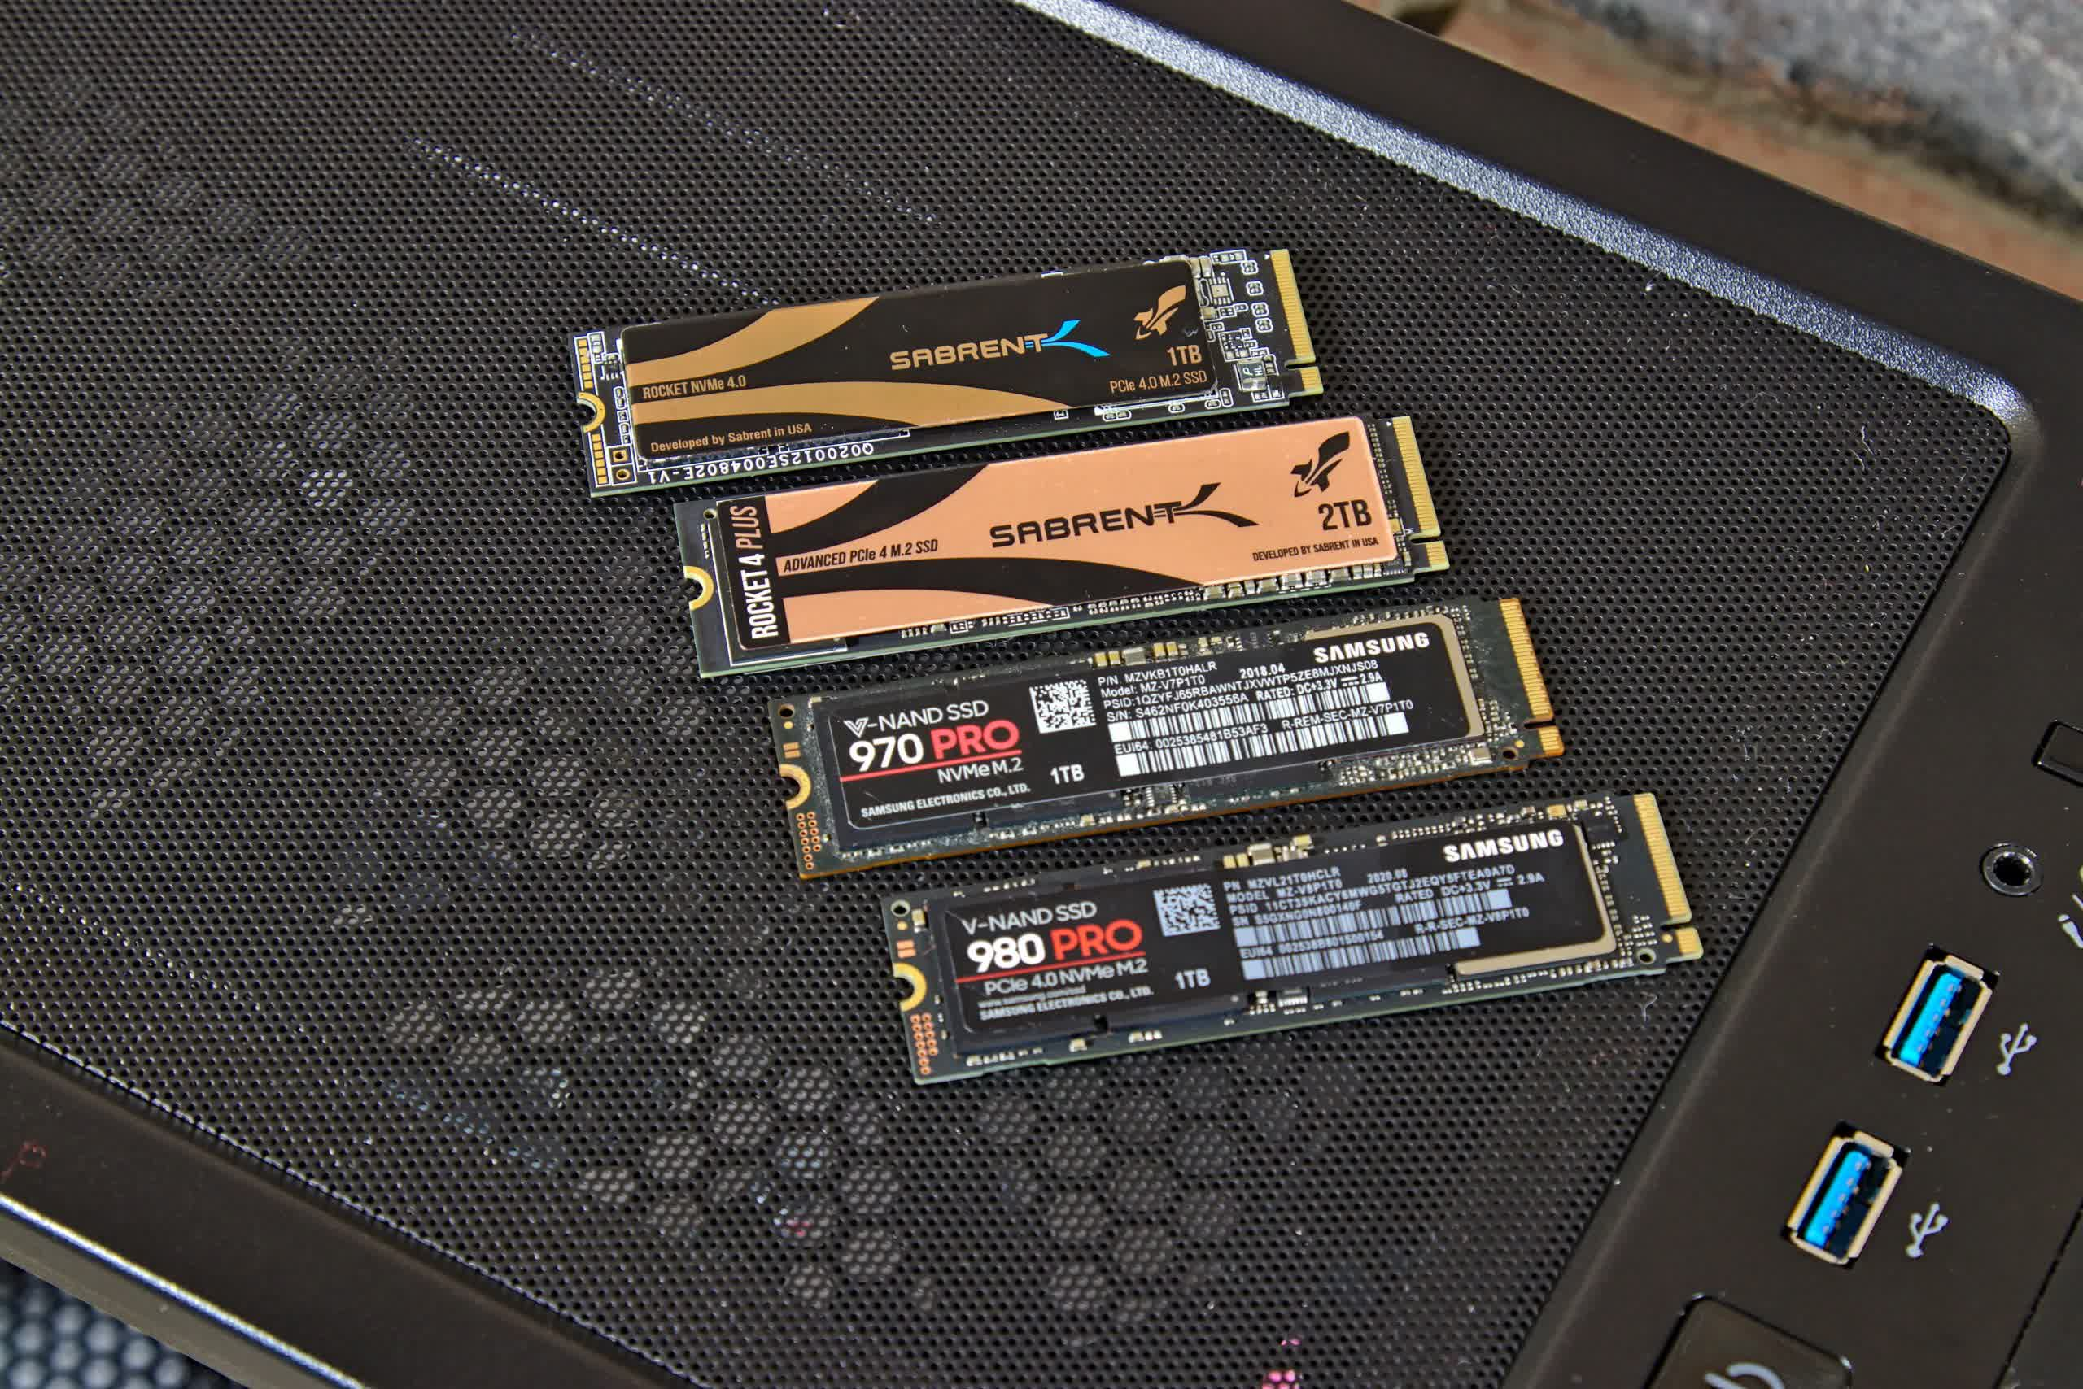

Considering all four drives, the Sabrent Rocket 4 remains the most cost-effective SSD on the market. If you're on a tight budget for a 1TB SSD, just go for it. However, we believe the Rocket 4 Plus is the ultimate winner. The 1TB variant is only $30 more, and it will be an excellent SSD for everyday usage.

However, if you do a lot of content creation or data-intensive job where you need to move large files around frequently, the extra $30 for the Samsung 980 Pro may be justified. For everyone else, conserving that money and putting it towards other parts of your construction is a good idea.